How To Change SAP System SID
https://blogs.sap.com/2013/11/21/how-to-change-sap-system-sid/

HI
I was changing my SAP System SID and i thought it will be useful to share the used procedure which is extracted from System Rename guide and Available SAP NOTES .

I Hope my first blog will be on expected Level at least for beginners .
This Blog explains how to rename an SAP system using software provisioning manager 1.0.Which is the successor of the product- and release-specific delivery of provisioning tools, such as SAPinst and part of the Software Logistics Toolset . for more information check SAP NOTE 1680045
It is valid for SAP systems based on SAP NetWeaver releases described on the following SAP NOTE 1619720 – System Rename for SAP Systems based on SAP NetWeaver
Available on SAP Service Marketplace at:
http://service.sap.com/sltoolset -> Software Logistics Toolset 1.0 -> Software Provisioning Manager.
by the way it is used also for
1- Installation, copy, and transformation for products based on SAP NetWeaver AS ABAP and AS Java
2- dual-stack split
3- System Rename
4- Frontend Installation and Distribution
You can rename the following SAP systems:
Systems installed by using the standard SAP tools.
Systems copied by using classical system copy (R3load/Jload or DB-specific procedure).
Systems created by using backup or restore with procedures offered by Microsoft Windows
Systems created by using SAP NetWeaver Landscape Virtualization management
Cloned systems (virtual to virtual, virtual to physical, or physical to virtual)
In the following case i am trying to change the SAP System SID , DB SID , and NR for theSource System
which is based on SAP NetWeaver 7.0x and Oracle DB and windows Server 2008 OS
SAP System SID = S6C
DB SID = S6C
Nr= 00
to New SID the Target System
SAP System SID = T11
DB SID = T11
Nr= 11
Constraints:
Rename can be performed on primary application server instances – additional application server instances have to be reinstalled
according to your OS download Software Provisioning Manager1.0 Package from SAP Service Marketplace at:
http://service.sap.com/sltoolset -> 1.0 -> Software Provisioning Manager
Log on to your SAP system
Extract the SAR file
Running the Software Provisioning Manager
On the Welcome screen, choose the following:System Rename ==> central System ==> SAP system Rename
Follow the instructions in the input screens AS shown in the following Step
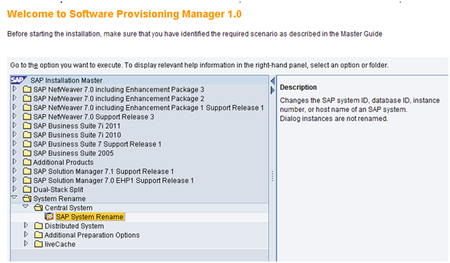
Select SAP System Rename
And Click Next
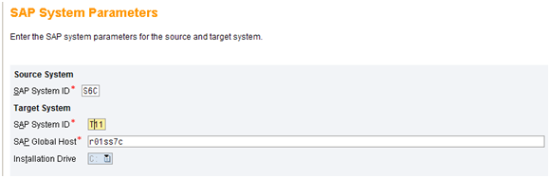
Enter the Required Parameter for source system (SID) and target System (NEW SID, Global Host and Installation Drive) And Click Next
SAP Global Host is giving by default
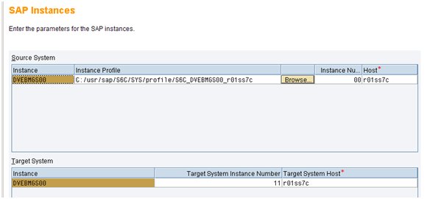
If you Plane to use Virtual Host Name Make sure that the the virtual host name is bound to local network interface
For the Target Instance Number
Do not use the following numbers:
43 – used by MSCS “in case you are using MSCS”
89 – used by Windows Terminal Server
Click Next
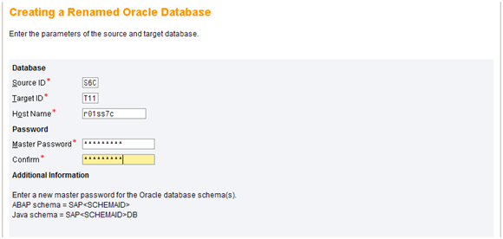
Enter the Source SID and Target SID and Host Name For the Database and New Password For Oracle Schema
Recommendation
Enter exactly the central instance number and SID that you have entered during the central instance installation.
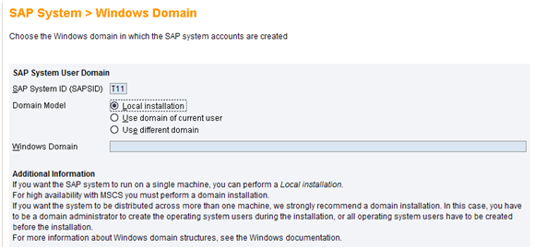
If you choose different domain you have to follow the procedure of Changing Windows Domain in System Rename guide
Click next
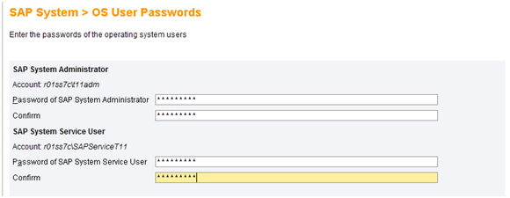
the above step will be required in case you did not perform Maintaining Users and Groups Step
Enter the Password for the following OS user (<SID>ADM ,SAPService <SID>)
Click Next
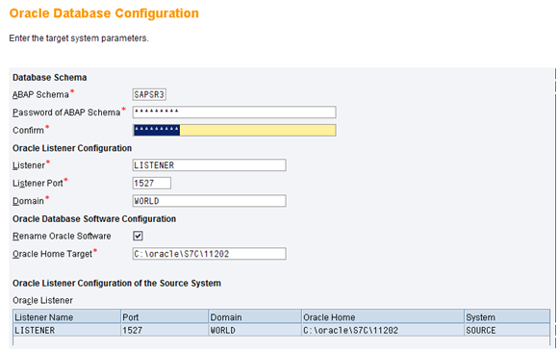
if you like to change the ORACLE HOME deselect the checkbox of rename Oracle Software
Click next
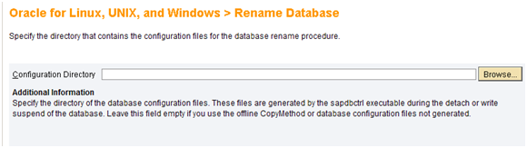
Leave the field Empty
Click Next
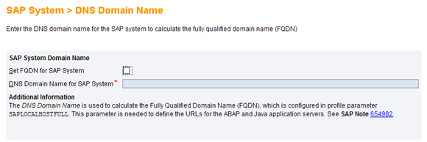
Click Next
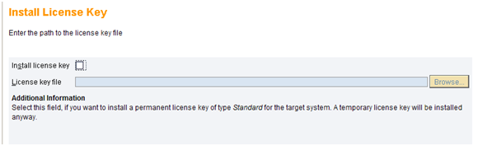
Click Next
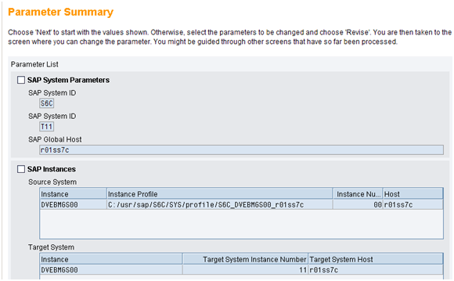
Make sure your SAP System IS down
Click Next
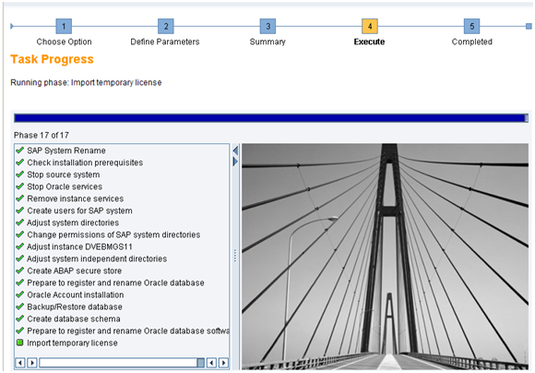
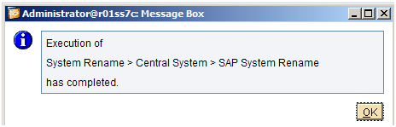
Click OK
System rename finished successfully
——————————————————-
Follow-up Activities
Potentially, all follow-up activities for a system copy are also valid for the rename of your SAP system For more information, see the system copy documentation
1- check the New SID name on OS Level in the following Directories
/usr/sap/SID
/Oracle/SID
2 – Logon to sap SAP system and as you have New Server Name Adapt your configuration accordingly
3- Run an installation check: Administration System administration Administration Installation Check(transaction SM28).
4- Perform server check (transaction SM51)
5- Adapt the Transport Management System (transaction STMS) According to the New SID if it is required
6- Delete all entries from the following tables: ALCONSEG, ALSYSTEMS, DBSNP, MONI, OSMON, PAHI, SDBAD, SDBAH, SDBAP, SDBAR as it is Contain log and Monitoring data related to the Old SID
7- Adapt all Background jobs needed in the SAP System
8- Adapt the definition of the printers to meet the new system
9- Adapt the RFC destination: (transaction SM59).
10- Adapt Your Operation Mode If it is configured
11- Adapt Your Logical System According to your naming convention was used
12- Adapt the instances and profiles
13- Adapt CCMS settings (for example, alert thresholds, reorganization parameters of CCMS table MONI) if required.
14- Replace all existing PSEs in the target systems with new ones, which contain the new system’s information
15- Add your System To the SLD
Restarting the SAP System
———————————————-
Best Regards

